ECOFIN - BACKGROUND GUIDE

Established in 1945, the Economic and Financial Affairs Council is one of the Second Committee of the United Nations General Assembly. It is a forum for the discussion of questions about economic growth and development, touching on macroeconomics, sustainable development, globalization, and economic policy. Its mandate explores groupings of nations such as the Least Developed Countries to encourage regional growth and support for all nations.
Some agenda items that often fall under the committee’s jurisdiction include the discussion and formulation of solutions to financial crises, addressing poverty in developing nations, and the handling of trade agreements between countries.
The committee hears the annual reports of its reporting bodies and evaluates requests for observer status in the General Assembly. Historically, the ECOFIN Committee has played a significant role in the Addis Ababa Action Agenda by creating a framework for financing sustainable development to further the UN’s Sustainable Development Goals.
ECOFIN delegates will deliberate on the economic implications of automation and artificial intelligence (Topic A) and cryptocurrency regulation and its impact on global financial stability (Topic B).

TOPIC A. The Future of Work: Addressing the Economic Implications of Automation and Artificial Intelligence
Introduction
The rapid growth of automation and artificial intelligence (AI) is actively transforming economics, reshaping how people live and work, affecting labor markets, and reshaping industries. The purpose of these forms of development is to improve efficiency, accuracy, and speed in business processes, with the overall objective of increased productivity and reduced costs in ways that cannot be achieved by people on their own. Automations have existed as early as 1st Century BC, with simple machines used to simplify tasks and improve productivity. The concept of artificial intelligence has existed for thousands of years but true manifestations of artificial intelligence in technology only started to be made in the 20th century.
Both automation and artificial intelligence can exist separately from one another, yet there are ways in which they are becoming more closely intertwined. Autonomous systems continuously facilitate the use of increasingly capable machines or devices that can perform tasks without human intervention, relying on AI to make decisions. AI and automation are increasingly becoming more critical in driving efficiency and productivity for humanity by eliminating common barriers to development, including slowness, human error, and other factors that can be premeditated and accounted for using machinery. These advancements come with the potential for job displacement, income inequality, and shifts in job industries, creating lasting impacts on worldwide economies that have shifted the culture and expectations around advancement for countries. The economic implications of automation and AI are critical for creating policies to implement a balance between people and a future powered by automation.

History of Automation and Artificial Intelligence
Background
The term “automation” dates back to the automobile industry, developed in 1946, describing the increased use of automatic devices and controls in mechanized production lines to facilitate the manufacturing items otherwise made inefficiently by people. Automation was present as early as in 1st century BC for grinding grain flour into flour, a process that would otherwise be done through long stretches of time by people. The additional use of falling water from water mills to create a mechanical process is seen as the dawn of “semi-automation” that would later lead to the automation evolution. Although simplistic forms of automation do not nearly scale up to the automation used today, the intent of these machines to lessen work burdens and improve productivity has stayed constant.
The Industrial Revolution represents a milestone in automation’s history, giving rise to the invention of steam engines, steam mills, and internal combustion engines that allowed for the discovery of technology that permitted people to be able to lead more efficient lives with the assistance of automobiles, the power loom, sewing machine, and the telegraph. The Industrial Revolution contributed to the increased wealth of middle-class workers and reduced the cost of goods for the average person by simplifying the production process. A caveat of these clear benefits is the exploitation of workers, specifically women and children, who were forced to work in dangerous conditions at lower wages. In sharp contrast, the second industrial revolution, which occurred from the late 19th century to the early 20th century, saw the rise of assembly-line production that encouraged standardization and mass production within factories. In a similar fashion to the first industrial revolution, jobs shifted towards mass production, but that was not the only impact on laborers. The use of automation systems resulted in rising wages for more monotonous work and the development of a middle class who had the means to purchase more affordable goods caused by price decreases.
The Third Industrial Revolution is classified primarily by a leap in automation for early computer systems, robotics, and increasing automated data processing. A much more critical time in the history of automation is the fourth industrial revolution which is currently ongoing. This era is characterized by the integration of artificial intelligence and machine learning, giving more capacity for machines to perform tasks that would otherwise require cognitive abilities possessed by humans. The first occurrence of AI as is known today appeared in 1950 in Alan Turing’s seminal paper Computing Machinery and Intelligence, where he established the criteria necessary to determine whether a machine can exhibit intelligent behavior to the standard of a human being. The term “artificial intelligence” was coined in 1956 during the Dartmouth Conference.
In the period from the 1950s to today, artificial intelligence’s capabilities have become nested under new and updated advancements. In the 1980s, the discovery of machine learning allowed for future AI systems to learn from historical data and adapt, followed by deep learning in the 2010s which permitted machine learning models to begin mimicking human brain functions. The current status of AI is a form of generative AI, that allows for deep learning models to create original content.
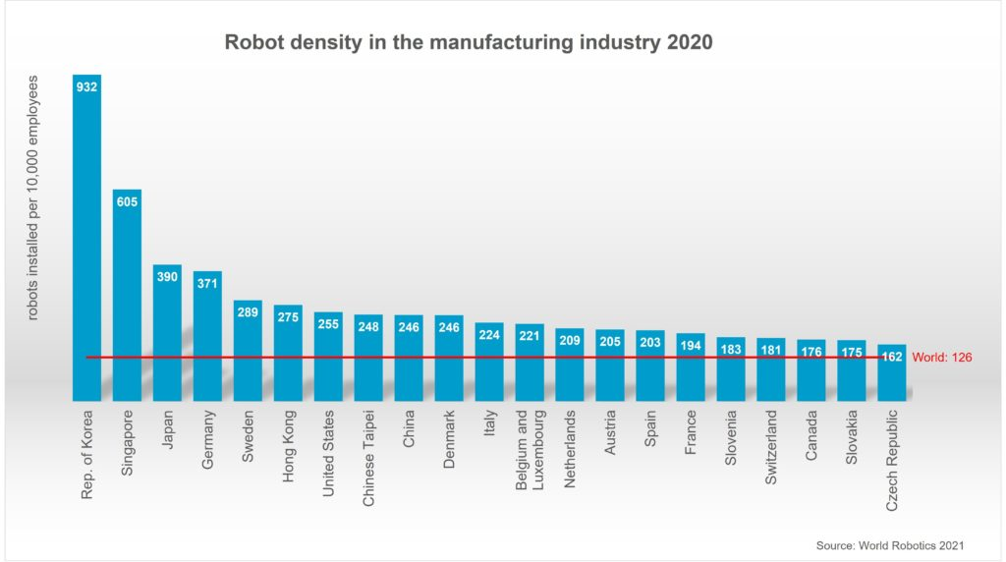
According to the International Federation of Robotics (IFR) There are more than three million industrial robots operating in factories around the world of which $13.2 billion of installations were brought about in 2020. A measure of robot density is utilized by the IFR to measure the number of robots per 10,000 workers in the industry. From 2015 to 2020, this metric doubled worldwide and has grown further. Asia has the highest robot density, measuring above the global average of 134 robots while Europe is slightly below the average, with 123 units.

Several studies corroborate the pressure rising automation and artificial intelligence has on job security and industry stability. In a study by the Pew Research Center, one out of five workers had what would be considered a high-exposure job, yet many U.S. workers were found to not feel their job was at risk by AI. Rather, 32% of workers in information and technology sectors claim AI helps more than harms them, in comparison to 11% who argue for greater harm than benefit. The economic forecast of AI projections estimated that AI’s economic impact will reach $15.7 trillion by 2030, at which point AI is expected to potentially replace 800 million jobs worldwide. This projection is supported by current measurements of job loss due to AI. In May 2023, 3,900 jobs in the US were linked directly to AI.
International Organizations Regulating Automation and AI
Through UNESCO, the UN has developed ethical guidelines in the face of artificial intelligence. In particular, the adoption of the Recommendation on the Ethics of Artificial Intelligence represented the first global standard-setting for ethics surrounding AI, which outlined topics of transparency, accountability, and discrimination. The European Union (EU) which ECOFIN has jurisdiction in through economic policies, has been at the forefront of furthering AI regulation. In April 2021, the European Commission proposed the “Artificial Intelligence Act,” which promised a framework for regulating AI applications depending on their apparent risk to ensure AI systems are safe for public use. In addition, the inclusion of General Data Protection Regulation provides implications for AI in prohibiting unfair use of consent, data usage, and data privacy,
In 2023, Congress held committee hearings and proposed several bills concerning AI that have faced several barriers to being passed, leaving the responsibility of establishing regulatory and compliance frameworks to states and federal legislations, leading states to be at the forefront of bill enactment and enforcement of AI regulation. Within the U.S., 17 states have enacted 29 bills focusing on ensuring data privacy and accountability, coming from states such as California, Colorado, New York, Oregon, Texas, and Washington.
The International Society of Automation, founded in 1945, is a non-profit association that seeks to “create a better world through automation,” through the development of standards ensuring safety, communication, and education on automation.
The OECD established AI Principles in response to a rising need for human-centric, transparent AI, which builds a framework for global interoperability between jurisdictions. The European Union, the Council of Europe, the United States, and the United Nations all use the OECD’s definition of AI systems and its regulation in legislative and regulatory frameworks. Within the AI Principles, the OECD describes value-based principles of transparency, democratic values, sustainable development, and accountability.
The Council of Europe’s role is to enforce human rights, democracy, and the rule of law. In the context of a growing digital environment, this role has expanded to respect and promote digital rights. The Council of Europe Framework Convention on Artificial Intelligence and Human Rights, Democracy, and the Rule of Law is a globally binding instrument that was designed to ensure AI upholds common standards in human rights. The framework aims to ensure activities within the “lifecycle of artificial intelligence systems” are fully consistent with human rights, democracy, and the rule of law, while also being conducive to technological advancement and development. It requires activities within the lifecycle of AI systems to comply with several fundamental principles, including equality and non-discrimination, provide procedural rights and safeguards, and provide impact management assessments.
UN Position
In an agreement between the UN and EU, the United Nations General Assembly (UNGA) has adopted the first global resolution on artificial intelligence, requiring countries to safeguard human rights, protect personal data, and monitor AI for risks. This non-binding resolution was proposed by the United States and co-sponsored by China and more than 120 member nations. The resolution introduces avenues to offer AI regulations, including a set of legally binding rules to govern AI risks, provided by the European Parliament. This movement towards AI regulation has encouraged the UK and US to sign the first bilateral agreement to jointly test advanced AI, allowing both parties to ensure AI tools and large language models do not pose a risk to users.
Automation Bias
Automation bias refers to the tendency to favor suggestions from automated decision-making systems and ignore contradictory information made without automation. This bias is prevalent in environments where decisions are supported by computer systems, including aviation, medical diagnosis, and financial forecasting. The reliance on automated systems has increased dramatically, causing errors of commission and errors of omission. Both errors result in the following incorrect suggestions and actions. A study of professional pilots found that more than half of them either disregarded important information when automated systems failed to notify them or made mistakes when systems provided false information.

Solutions and Recommendation
The economic implications of automation and AI require a multifaceted approach that prioritizes workforce adaptation and will need safety measures to be implemented. A possible solution for these rises in automation is to work with governments to develop upskilling initiatives that work in tandem with education systems to increase the skill skits of workers and allow them to qualify for higher-entry jobs that may be a result of AI implementation.
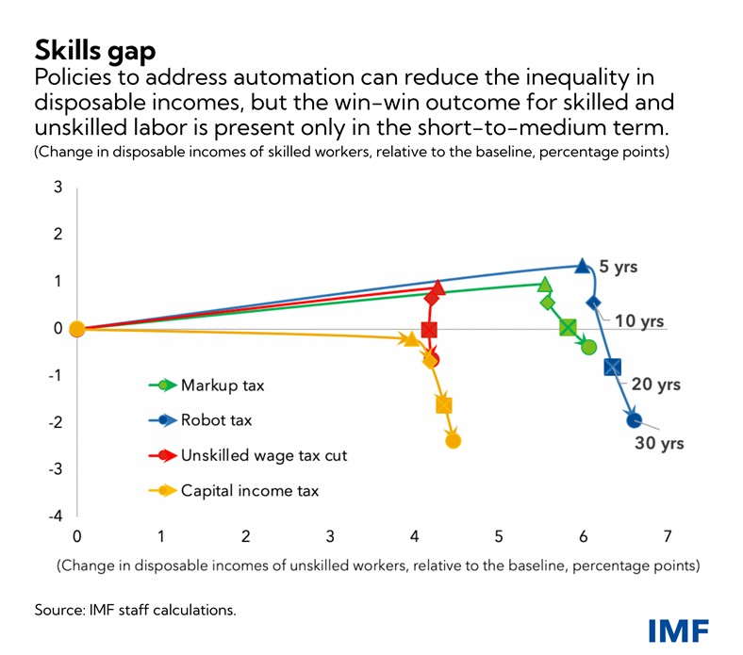
Mitigating the economic influences of worker displacement could be through providing social welfare and incentives for companies to maintain their workforce and not as easily prioritize mass production or automation for all aspects of work.
Fiscal policy instruments can also be used to reduce inequality nad reduce the cost of forgone growth. In particular, specific taxes may be useful in being able to reduce inequality that is concurrent with economic harms, addressing the equality-efficiency loss by taxing excess profit of firms with market power in an automated economy.

By utilizing government spending and tax policies, the trade-off between economic growth and inequality as a result of innovation and automation can be reduced without incurring significant harm to the parties involved.

Bloc Positions
Developed Economies
In developed economies, such as the United States, Western Europe, and Japan, automation and AI are viewed as essential tools for maintaining global competitiveness. These countries are focused on integrating these technologies to boost productivity and innovation. However, they also face concerns about job displacement, increased inequality, and the need for significant workforce reskilling. Developed economies generally support policies that encourage technological advancement, but they emphasize the importance of robust social safety nets, retraining programs, and educational reforms to help workers transition to new roles in an AI-driven economy.

Emerging Economies
In emerging economies, including India, Brazil, and South Africa, there is a more cautious approach to the widespread adoption of automation and AI. While these countries recognize the potential benefits of automation in driving economic growth and improving efficiency, they are also aware of the risks it poses, particularly for sectors such as manufacturing, which rely on labor-intensive work. These countries are likely to support policies that promote gradual automation adoption, combined with strong investments in education and infrastructure to ensure their workforce can adapt to the changes brought by automation​.

Developing Countries
For developing countries, such as those in Sub-Saharan Africa and Southeast Asia, automation presents significant challenges. Many of these nations depend on labor-intensive industries, and the rapid adoption of automation could lead to widespread job losses, with limited infrastructure to support displaced workers. These countries are likely to advocate for international cooperation and financial assistance to develop the necessary educational and technological infrastructure, enabling them to manage the transition to a more automated economy while prioritizing job creation and economic inclusion.

Technology-Heavy Economies
In technology-heavy economies, such as South Korea, China, and Singapore, automation and AI are seen as critical to maintaining global leadership in innovation and production. These countries are heavily investing in advanced technologies to stay competitive, but they are also aware of the social implications, such as job displacement and increased inequality. These economies are likely to advocate for policies that balance continued technological development with programs that reskill and support workers, ensuring that the benefits of automation are shared more equitably across society.

QARMA (Questions a Resolution Must Answer)
- How can countries ensure that automation and AI promote economic growth without disproportionately displacing workers, particularly in labor-intensive industries?
- What strategies can be implemented to retrain and reskill workers whose jobs are at risk due to automation and AI?
- How can governments and businesses collaborate to ensure that the benefits of automation and AI are equitably distributed across society, particularly for low-income and marginalized workers?
- What policies should be enacted to prevent automation and AI from exacerbating global inequality between developed and developing economies?
- How can international organizations, such as the International Labour Organization (ILO), help coordinate global efforts to manage the socioeconomic impacts of automation and AI?
- What ethical guidelines should be established to govern the use of AI in the workplace, particularly in relation to data privacy, algorithmic bias, and human oversight?
- What role should governments play in incentivizing businesses to invest in technologies that complement rather than replace human workers?

Conclusion
In preparing to engage in a discussion of automation and artificial intelligence, it is important to remember that the implications of these advancements come with several benefits and consequences. Automation and artificial intelligence have been critical in determining the rates of growth for societies and the facilitation of fast-speed development in underdeveloped societies. Artificial intelligence and automation have the capacity for great influence and benefit based on their capability to increase welfare and productivity, yet come with several consequences.
The debate on the implications of automation and AI can be viewed from countless perspectives, each arising from unique beliefs that take into account the social, political, and economic power of these advancements. It is the duty of the committee to explore several solutions that would be able to approach this subject and ensure that the implications of automation and AI are limited and minimize danger to humanity. Delegates should focus on the alternative sides of this topic and the regulatory opportunities that exist to be able to provide frameworks and systems for preventing abuses of humanity through the use of technology, balancing personal interests with the protection of rights.

TOPIC B. Cryptocurrency Regulation and Its Impact on Global Financial Stability
Introduction
Concepts for a truly digital system for financial transactions and currency have been discussed by leaders in finance and technology since the 1980s. The goal of many cryptographers, those with a focus on encoding sensitive information, has been to create a system for cash flow that is both decentralized, in that it lacks a need for government regulation, and anonymous, in that it conceals sensitive user information. Such goals came to fruition with the introduction of Bitcoin in 2009, the first successfully usable decentralized currency of its kind.
Cryptocurrencies work by running transactions on a blockchain, a distributed and secure ledger for financial transactions. Users have access to their virtual wallet, and when they send 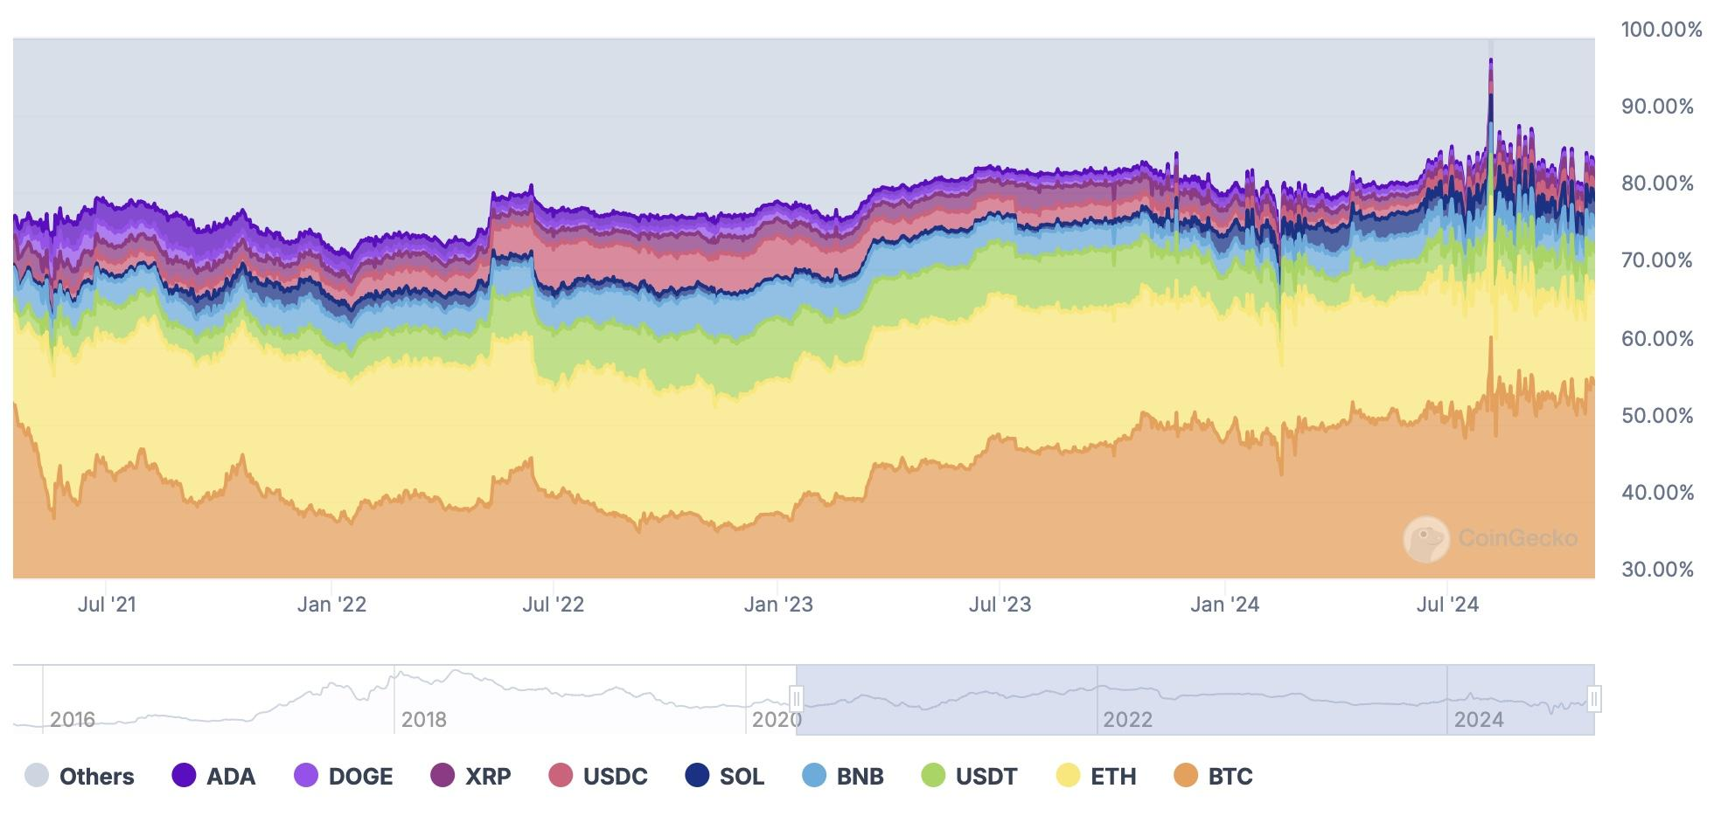funds to another user, that transaction is recorded as a series of numbers called ‘block’, which is verified by the blockchain network. Such a system drops the need for storing sensitive personal information, such as names, addresses, and governmental identification numbers, hence making it anonymous. It also makes the need for a central government or overseeing bank to verify transactions, allowing cryptocurrency to be decentralized. Since Bitcoin’s launch in 2009, several other cryptocurrencies have garnered attention and popularity, the most popular being Etherium, DogeCoin, Shiba Inu, and Cordana. A vast majority of the most known cryptocurrencies today are capped at a fixed price, like Bitcoin at 21 million coins. Users can ‘mine’ for cryptocurrency by using large networks of computers to solve complex math problems, the solutions to which unlock access to a certain amount of crypto money.
However, many economists warn of the instability of crypto currencies, citing their inability to compete with traditional currencies’ stability of value and transaction cost. Traditional currencies, determined by central banks, are designed to fluctuate in value to account for changes in at-large demands, maintaining an elastic supply of money. As a result, traditional currencies fluctuate more slowly in value and are generally reliable when converting to other traditional currencies. Crypto, on the other hand, relies on a fixed money supply so it may be mined properly, meaning fluctuations in demand will keep the currency value changing with it. The result is drastic dips and spikes in currency value and transaction fees, even among cryptocurrencies designed to maintain stability in value. While crypto ownership has become increasingly popular, especially in developed economies such as the United States where 17% of adults own cryptocurrency, the novel financial system may have more destabilizing effects than were intended from its creation.
- History - Alan
El Salvador Adoption of Bitcoin
Although many countries allow varying degrees of cryptocurrency usage, individuals with digital wallets are confined to spending in a digital environment. That was, until El Salvador became the first country to adopt crypto currency, Bitcoin specifically, as legal, acceptable tender within its borders. The Central American country also launched Chivo Wallet, a banking app that allows users to make withdrawals, payments, and transfers, only through Bitcoin.
The adoption of Bitcoin was an experiment in bridging the divide between government-run legal tender and digital, decentralized currency. The results of this experiment demonstrates a path of struggle for the country. The Salvadoran government made great efforts to advertise the change and the app, as well as giving its citizens incentives to use it, like a $30 subsidy. Chivo Wallet also boasted low transaction fees compared to Bitcoin elsewhere. Theoretically, making Bitcoin legal tender in a country where a majority of people have no bank account and almost 90% have never used mobile banking would make this financial technology more accessible to all.
Still, despite 68% of El Salvador’s population knowing about Chivo Wallet and 54% trying to use it, less than 10% used the app for Bitcoin after spending their $30 subsidy. Further investigation revealed that a majority of regular users were young, educated, men familiar with banking services, leaving the intended population of this project largely unreached and unaffected.
In 2023, the University of Central America found that 88% of Salvadorans do not use Bitcoin; many cite concerns about the volatility of prices in a community of people who largely earn just enough to eat and shelter themselves. Bitcoin comprises just 1% of remittances, despite crypto’s emphasis on easier international transfers. Locals across the country say they are more concerned with unstable prices and rising cost of living as a result of crypto. This suggests an existing financial barrier of entry to cryptocurrency usage, barring low-income communities with less room for risk.
Despite the citizenry of El Salvador largely ignoring the addition of Bitcoin, the move has sparked controversy in the international community. The IMF has urged Salvadoran President Nayib Bukele to reverse his adoption of Bitcoin, noting it would be difficult for the country to receive a loan from the fund as a result. The IMF has cited concerns about consumer protection and financial stability, and with reason. At the end of 2022, the value of Bitcoin fell 45%, costing the El Salvador National Reserve $22 million. Since then, the value has somewhat stabilized, but the majority of Bitcoin transactions in El Salvador’s main cryptocurrency hubs are done by tourists, not citizens of the country. El Salvador continues to work with the IMF to develop a stable system for regular cryptocurrency transactions.
Cryptocurrency Regulatory Organizations
MICA
In response to the growing concerns surrounding cryptocurrency and its use, the European Union issued the Markets in Crypto-Assets Regulation, known as MiCA. This framework aims to address some key risks associated with the proliferation of crypto assets. Some of these points include ensuring prospective customers are informed of the characteristics and functions of their crypto-assets, safeguarding blockchains against hacks and bugs that leave it vulnerable to market abuse, and reducing the risk of fraud, money laundering, and financial terrorism. The issue of crypto-security more broadly has been discussed by the European Commission since 2018, and MiCA was passed by EU legislation in 2023.
At a technical level, MiCA differentiates between different types of crypto-assets, known as tokens: there are utility tokens, e-money tokens, and asset-referenced tokens, which are separated based on what kinds of value they represent. Each type of token comes with an associated set of regulatory rules, including comprehensive documentation and potentially a license under a subset of permissions allotted to the type. This required documentation is a part of a push for greater transparency among cryptocurrency providers and users as to the services and limitations of their digital technology.
One key aspect of MiCA that makes it so comprehensive is its ‘travel rule’, a clause that specifies that information related to the source of the asset must travel with the transaction so it may be reachable from the destination. This is to prevent a common money laundering strategy known as ‘mixing’, in which source information becomes unreachable from its destination.
While MiCA may be detrimental to digital currency providers who were unprepared to follow it, the regulation is expected to benefit many in the European Economic Area. MiCA’s regulations give financial institutions and governments a green light to collaborate with crypto currencies deemed ‘safe’ under the licensing and rules. Furthermore, these regulations will keep the overall European economy safe from sharp price fluctuations.
Despite being deemed the most comprehensive cryptocurrency regulation in the world, MiCA still encounters limitations. The regulations have not yet been extended to non-fungible tokens (NFTs) and decentralized finance, a form of crypto entirely removed from third parties, considered the least regulated form. Furthermore, while MiCA requires cryptocurrency providers to release an environmental impact report, they do not yet impose specific regulations on environmental impact. These potential aspects of MiCA are being debated and may enter into the regulations in some form in years to come.
Other National Regulations
Other countries have adopted varying methods for regulating cryptocurrency usage. For example, as of 2022, the United States of America had no national regulations surrounding cryptocurrency. Instead, cryptocurrency regulations were left up to individual states, who at the time, experienced varying levels of oversight, with some states adopting both cryptocurrency and blockchain regulations and other states having neither.
In May 2024, this changed with the passing of the Financial Innovation and Technology for the 21st Century Act, which imposes restrictions on cryptocurrency markets similar to MiCA. It requires segregation from institutional funds from consumer funds and public transparency from brokers, dealers, and exchanges to consumers as to the institution’s ownership. It also outlines the differences between which crypto assets qualify as securities and which ones are commodities. However, this act fails to enact a ‘travel rule’ like in MiCA. This act is a part of a larger push within the USA to tighten crypto regulations, known as the Framework for International Engagement on Digital Assets.
Many developed economies have enacted strikingly similar clauses. Japan recently toughened its regulations on crypto exchanges, requiring more customer information documented in each exchange in an effort to combat money laundering. China is much stricter, with a ban on cryptocurrency exchanges, trading, and mining. Brazil takes a different approach to regulation, with the government acting as a central bank that supervises crypto assets within the country.
UN Reactions
The United Nations has been involved in both cryptocurrency advancement and regulation. UNICEF Ventures began exploring cryptocurrency’s potential benefit for children. The project has promoted and incentivized the creation of open-source digital public goods for the purpose of streamlining UNICEF funding and projects worldwide. Further, UNICEF is researching how blockchain technology can be leveraged to connect schools and provide real-time access to information and resources. Overall, this project is aimed at funding local educational projects and working with UNICEF partner organizations in a more efficient way.
However, the UN Conference on Trade and Development has previously warned of the danger of developing economies adopting crypto technology too quickly. Cryptocurrencies globally pose a risk as legal tender, as they could jeopardize the monetary sovereignty of many countries. In developing economics specifically, cryptocurrency proliferation could unofficially replace the country’s recognized currency, which would hurt currencies with already unmet demands for currency reserves. As one UN perspective, UNCTAD’s main concern is that crypto being accepted as currency in a developing economy could curb the government’s ability to effectively utilize capital controls and maintain a stable y with steadily inflating prices.economy. This poses a threat to all those living in a developing nation, especially those without access to cryptocurrency banking. While proponents of crypto cite its aid in remittances, there are potential barriers to adopting such technologies fully, such as the risk of mass tax evasion.
Cryptocurrency and Money Laundering
One significant danger of the deregulated property of cryptocurrency is the absence of an agency who prevents related crime. Many working in criminal industries globally exploit this legal vulnerability to partake in an array of illegal activity, far from under the scrutiny of a central law-enforcing body. This phenomenon is becoming increasingly documented, and international governments have begun identifying crypto-related crime. According to a report by Europol, the EU’s primary law enforcement agency, money laundering operations have expanded and moved to a digital space with the proliferation of crypto transactions. In 2020, the agency led a joint investigation with the U.S. Department of Justice involving twenty countries, which discovered the tens of millions of euros stolen in a laundering scheme on the QQAAZZ digital network. Europol commented that mass money laundering schemes that occur through cryptocurrency are largely organized by those experienced in the practice; they are often prepared with multiple bank accounts and extensive knowledge of the financial technology sector.
Cryptocurrency not only lacks crime regulation, it also lacks basic user regulation. UNODC, the United Nations Office on Drugs and Crime, outlines some of the vulnerabilities associated with cryptocurrency’s digital nature. They advertise that it takes mere seconds to create and use an account address free of cost, unlike a physical bank which often requires registration, identification, and government oversight for a user to transact. Furthermore, tracking the legitimacy of sudden and unexpected wealth proves more challenging on this digital medium due to crypto’s rapidly growing exchange rates, with some currencies reaching 10,000%. With the advent of crypto ‘mixers’, which funnel and disperse funds across accounts to make their source and destination untraceable, governments are increasingly struggling to enforce laws against crypto crime.
Such a challenging issue requires a high degree of international cooperation, and global economies have responded to an uptick in digital financial crime accordingly. Thirty seven countries from all inhabited continents comprise the Financial Action Task Force (FATF) researches global money laundering practices and prevention methods, as well as its role in terrorism. Within their guidelines, the FATF recommends countries to regulate the technologies produced by its corporations and ensure they are compliant with the Responsible Business Alliance.
These guidelines also cite national laws of its members that seek to uphold principles of cryptocurrency safety. However, the variety in crypto’s acceptance as legal tender among its members gives way to vastly differing levels of government scrutiny, even within the organization. However, it’s largely undisputed among global economies that cryptocurrency makes financial crime prevention significantly more challenging to detect, track, and prosecute.
Circumventing Russian Sanctions
Since 2014, countries have begun sanctions against Russia due to its military involvement in Crimea. In February 2022, sanctions increased in strength and global participation due to Russia’s invasion of Ukraine. However, Russian financial institutions have utilized digital assets to circumvent these sanctions, pooling illegal funds that support the country’s military operations. In November 2023, the Office of Foreign Assets Control (OFAC) sanctioned Russian national Ekaterina Zhdanova for laundering and moving money on behalf of Russian elites. According to reports of this sanction, she used entities such as Garantex, which lack anti-money laundering and anti-financial terrorism technologies.
International governments have responded through increased sanctions. Many states have tightened visa restrictions, particularly for Russian software developers and those working in financial technology. Russia has responded with the proliferation of organizations aimed at assisting the evasion of sanctions. A joint stock company known as Marshal.Global (MarGlo) is a Moscow-based financial institution whose goal is to provide financial services to Russian elites sanctioned by other governments. MarGlo utilizes the anonymity of some cryptocurrencies to remain hidden from the scrutiny of international governments.
However, Russian citizens against the war looking to leave are finding themselves caught up in the mix. One such example is Olga Shkolina, a Russian activist who fled to Poland shortly after Ukraine was invaded. She explained to a new source that, as a result of being a Russian citizen, she can no longer access her frozen digital wallet. Thus, the digital sanctions imposed on Russia leaves well-intentioned citizens unable to access funds, while those experienced with financial technologies find ways to bring cryptocurrency into Russia from sanctioning countries.
Environmental Concerns
The proof-of-work (PoW) system by which cryptocurrencies like Bitcoin validate funds from mining require the computation of difficult to solve math problems. However, these problems cannot be solved quickly enough by a standard house computer. Instead, Bitcoin mining is done by large, complex computer networks in facilities that require significant water and energy. In 2018, Bitcoin mining used energy on a scale comparable to Hungary or Switzerland. In recent years, as Bitcoin operations have grown and mining has become more difficult to extract funds due to more competing firms, that annual energy use has roughly tripled.
Furthermore, Bitcoin mining has a significant impact on carbon emissions, seeing as coal accounts for 45% of the energy fuel supply of Bitcoin mining. It’s unsurprising that Bitcoin miners favor naturally cooler locations in far-northern climates such as Norway, Sweden, and Russia to offset the greenhouse gas and heat impact of the mining process. Norway and Sweden particularly are among the top ten countries using the most natural resources for mining, when land and water is factored into the calculation.
As a result, Bitcoin mining has become a controversial issue among these cooler-climate countries, many of which have extensive existing efforts to preserve their climate and natural environment, as well as coastal and island nations, who are already facing devastating impacts of climate change through rising sea levels. According to several professors and researchers of economics at the University of New Mexico, as cryptocurrency mining continues to proliferate, the environmental impacts are already significant and visible, and they may lead to greater future costs due to associated environmental externalities. These issues are exacerbated in developing economies, which are relatively unequipped to handle adverse rapid climate change than their economically developed peers.
Existing Solutions and Recommendations
Cryptocurrency scrutiny and regulation has been implemented in much of the economically developed world. However, with these regulations come innovative ways to overcome them and illegally transfer funds. Many organizations, including the FATF, stress the importance of international cooperation when combating financial terrorism, money laundering, tax evasion, and theft through cryptocurrency. However, international agents working to professionally circumvent sanctions make these efforts more challenging to realize.
To tackle environmental concerns, some cryptocurrencies use Proof of State (PoS) rather than PoW mining systems. These currencies are less environmentally taxing to mine since they don’t require solving complex math problems. Rather, the mining process is more random, with validators more likely to earn based on the number of ‘coins’ they stake. However, competitive mining firms favor the reward-based approach since they can compete with optimal solving methods and algorithms.
UNCTAD recommends a halt to the proliferation of cryptocurrency in developing nations. They urge governments to limit cryptocurrency advertising and tighten government controls surrounding emerging crypto technologies. However, some countries like El Salvador see an opportunity to jump on the growing trend and disregard these recommendations in favor of partnering with cryptocurrency leaders to boost crypto use and their economy. It remains pertinent to the structure of this committee that any actions taken preserve the national and economic sovereignty of each country while protecting the economic interests of those most impacted by the economic instability of cryptocurrency.

Bloc Positions
Developed Economies
In developed economies, such as the United States, Western Europe, and Japan, the focus is on striking a balance between embracing cryptocurrency innovation and ensuring financial stability. These countries generally advocate for strict regulatory frameworks to mitigate the risks associated with cryptocurrencies, such as market volatility, fraud, and cybercrime. The United States and the European Union, in particular, have pushed for frameworks like the Markets in Crypto-Assets (MiCA) regulation, aiming to safeguard traditional financial systems while allowing for controlled innovation. Developed economies are also concerned about the potential for cryptocurrencies to disrupt their monetary policies and regulatory standards​.
Emerging Economies
In emerging economies, including countries like India, Brazil, and South Africa, the approach to cryptocurrency regulation is more cautious. These countries recognize the potential of cryptocurrencies to promote financial inclusion and innovation, particularly in regions with underdeveloped banking infrastructures. However, they are also wary of the risks posed by unregulated cryptocurrency markets, including capital flight and economic instability. Emerging economies are likely to support international regulatory frameworks that balance the need for innovation with measures to protect their financial systems from external shocks.​
Developing Countries
For developing countries, particularly in regions like Sub-Saharan Africa and Southeast Asia, cryptocurrencies offer the potential to improve financial inclusion in areas where access to traditional banking is limited. However, these countries face significant risks, such as market volatility and the lack of regulatory capacity to manage cryptocurrency adoption. Developing countries are likely to advocate for international cooperation and technical assistance to help build their regulatory frameworks, while promoting the responsible use of cryptocurrencies to enhance economic inclusion and reduce financial exclusion.​
Cryptocurrency-Currency Heavy Economies
In cryptocurrency-heavy economies, such as El Salvador, Venezuela, and Russia, the primary focus is on leveraging cryptocurrencies to achieve financial autonomy and circumvent economic sanctions. These countries are more resistant to strict global regulations, as they view cryptocurrencies as tools for economic sovereignty and an alternative to volatile domestic currencies. However, they also face significant risks, such as extreme volatility in crypto markets and the potential for increased financial instability. These economies are likely to push back against global regulatory efforts that they perceive as limiting their economic flexibility.​
Environmentally-Concerned Nations
In environmentally concerned nations, such as Scandinavian countries and Germany, there is also a focus on the environmental impact of cryptocurrency mining, particularly the energy-intensive processes of Bitcoin mining. These countries are advocating for stricter environmental regulations on cryptocurrency activities and are pushing for greener technologies that can reduce the carbon footprint of crypto operations. Additionally, they are likely to support transparency initiatives to ensure that cryptocurrencies are used in an environmentally sustainable way​.

QARMA - (Questions a resolution must answer)
- How can international regulatory frameworks balance the promotion of cryptocurrency innovation with the need to safeguard global financial stability?
- What measures can be taken to protect consumers and investors from the risks of fraud, market volatility, and cybercrime associated with cryptocurrency use?
- What role should international financial institutions, such as the International Monetary Fund (IMF) and World Bank, play in regulating and monitoring the impact of cryptocurrencies on global financial markets?
- How can cryptocurrencies be regulated to prevent their use in illicit activities, such as money laundering and terrorist financing, while preserving the legitimate uses of decentralized finance?
- How should countries address the environmental impact of cryptocurrency mining, particularly in relation to energy consumption and carbon emissions?
- How can developing countries be supported in building the regulatory capacity necessary to manage the risks and benefits of cryptocurrency adoption?
- What safeguards should be in place to prevent cryptocurrencies from undermining traditional monetary policies and central banking systems?
- How can global cooperation be strengthened to ensure consistent and effective cryptocurrency regulation across different jurisdictions, preventing regulatory arbitrage?

Conclusion
As you prepare to engage in meaningful discussions on the regulation of cryptocurrency, it is essential to understand the far-reaching implications these digital assets have on global financial stability. Cryptocurrencies, with their decentralized nature and anonymity, offer both opportunities and risks. On one hand, they promote financial inclusion and innovation, particularly in regions where traditional banking systems are underdeveloped. On the other hand, their volatility, susceptibility to illicit use, and potential environmental impact present significant challenges for regulatory bodies across the world.
The debate on cryptocurrency regulation is multifaceted, involving developed, emerging, and developing economies, each with unique concerns and perspectives. As regulations like the European Union’s MiCA framework and the US Financial Innovation and Technology for the 21st Century Act demonstrate, there is a global effort to strike a balance between fostering innovation and protecting financial systems. However, the conversation is far from over, particularly for nations like El Salvador, which have adopted cryptocurrencies as legal tender, and environmentally-conscious countries advocating for greener mining technologies.
Moving forward, it will be up to this committee to explore solutions that can bridge the gap between innovation and regulation, ensuring that cryptocurrencies can contribute positively to the global financial landscape while minimizing risks. Delegates should focus on creating regulatory frameworks that are adaptable to the fast-evolving world of digital finance, balancing national interests with international cooperation.
We urge all delegates to come prepared with a strong understanding of their country’s position on cryptocurrency regulation, as well as potential solutions that can be applied on a global scale. This topic presents an opportunity to develop policies that could shape the future of finance, and we look forward to seeing the innovative resolutions that emerge from our discussions.

https://money.usnews.com/investing/articles/the-history-of-bitcoin
https://www.security.org/digital-security/cryptocurrency-annual-consumer-report/#popular
https://www.cfr.org/backgrounder/crypto-question-bitcoin-digital-dollars-and-future-money#chapter-title-0-2
https://www.bis.org/publ/arpdf/ar2018e5.htm
https://www.europol.europa.eu/cms/sites/default/files/documents/Europol%20Spotlight%20-%20Cryptocurrencies%20-%20Tracing%20the%20evolution%20of%20criminal%20finances.pdf
https://syntheticdrugs.unodc.org/syntheticdrugs/en/cybercrime/launderingproceeds/moneylaundering.html
https://www.fatf-gafi.org/content/dam/fatf-gafi/guidance/Guidance-RBA-Virtual-Currencies.pdf.coredownload.inline.pdf
https://insights.som.yale.edu/insights/el-salvador-adopted-bitcoin-as-an-official-currency-salvadorans-mostly-shrugged
https://www.reuters.com/technology/short-cash-el-salvador-doubles-down-bitcoin-dream-2024-02-02/#:~:text=Some%2088%25%20of%20Salvadorans%20did,remittances%20were%20sent%20in%20bitcoin.
https://www.nber.org/digest/202207/el-salvadors-experiment-bitcoin-legal-tender
https://www.bbc.com/news/world-latin-america-60135552
https://www.washingtonpost.com/world/2022/01/26/el-salvador-bitcoin-dip-crypto-crash/
https://www.esma.europa.eu/esmas-activities/digital-finance-and-innovation/markets-crypto-assets-regulation-mica
https://finance.ec.europa.eu/digital-finance/crypto-assets_en#
https://www.whitecase.com/insight-alert/mica-regulation-new-regulatory-framework-crypto-assets-issuers-and-crypto-asset
https://www.acfcs.org/eu-passes-landmark-crypto-regulation
https://www.pwc.nl/en/insights-and-publications/services-and-industries/financial-sector/european-regulation-has-huge-impact-on-crypto-assets.html
https://stevenscenter.wharton.upenn.edu/publications-50-state-review/
https://financialservices.house.gov/news/documentsingle.aspx?DocumentID=409277
https://www.britannica.com/technology/automation
https://www.progressiveautomations.com/blogs/news/the-evolution-of-automation
https://www.weforum.org/agenda/2024/05/global-cryptocurrency-regulations-changing/
https://home.treasury.gov/news/press-releases/jy0854
https://www.csg.org/2023/12/06/artificial-intelligence-in-the-states-emerging-legislation/
https://unctad.org/news/unctad-spells-out-actions-curb-cryptocurrencies-developing-countries
https://www.weforum.org/agenda/2022/11/the-macroeconomic-impact-of-cryptocurrency-and-stablecoin-economics/
https://www.imf.org/en/News/Articles/2024/09/06/sp090624-artificial-intelligence-and-its-impact-on-financial-markets-and-financial-stability
https://news.un.org/en/story/2022/08/1124362
https://unu.edu/press-release/un-study-reveals-hidden-environmental-impacts-bitcoin-carbon-not-only-harmful-product
https://www.imf.org/en/Blogs/Articles/2024/01/14/ai-will-transform-the-global-economy-lets-make-sure-it-benefits-humanity
https://home.dartmouth.edu/news/2022/06/study-slowing-down-automation-may-have-economic-benefits
https://news.un.org/en/story/2024/09/1153906
https://www.un.org/en/desa/will-robots-and-ai-cause-mass-unemployment-not-necessarily-they-do-bring-other
https://finintegrity.org/russian-use-of-crypto-sanctions-evasion-on-rise/
https://home.treasury.gov/news/press-releases/jy0731
https://www.marketplace.org/2023/09/25/eu-russia-crypto-sanctions/
https://grc.studentorg.berkeley.edu/the-sustainability-of-bitcoin-and-its-impact-on-the-environment/
https://unu.edu/press-release/un-study-reveals-hidden-environmental-impacts-bitcoin-carbon-not-only-harmful-product
https://www.nature.com/articles/s41598-022-18686-8#Sec9
https://www.investopedia.com/terms/p/proof-stake-pos.asp
https://www.ibm.com/topics/artificial-intelligence
https://www.therobotreport.com/10-most-automated-countries-wordlwide-in-2020/
https://www.pewresearch.org/social-trends/2023/07/26/which-u-s-workers-are-more-exposed-to-ai-on-their-jobs/
https://seo.ai/blog/ai-replacing-jobs-statistics#:~:text=14%25%20of%20workers%20claim%20to,a%20job%20to%20'robots'.&text=In%20May%202023%2C%203%2C900%20US,were%20linked%20directly%20to%20AI.&text=British%20Telecom%20aims%20to%20replace%2010%2C000%20staff%20with%20AI%20within%207%20years.&text=Early%20AI%20and%20automation%20have,up%20to%2070%25%20since%201980.
https://oecd.ai/en/ai-principles
https://www.coe.int/en/web/artificial-intelligence/the-framework-convention-on-artificial-intelligence#what
https://www.weforum.org/agenda/2024/04/artificial-intelligence-technology-news-april-2024/#:~:text=The%20United%20Nations%20General%20Assembly,and%20monitor%20AI%20for%20risks.
https://www.forbes.com/sites/brycehoffman/2024/03/10/automation-bias-what-it-is-and-how-to-overcome-it/
https://www.britannica.com/event/Industrial-Revolution
https://www.museumoftolerance.com/assets/documents/children-who-labor-handout-2.pdf
https://mpra.ub.uni-muenchen.de/110972/
https://academic.oup.com/mind/article/LIX/236/433/986238
https://www.unesco.org/en/artificial-intelligence/recommendation-ethics
https://digital-strategy.ec.europa.eu/en/policies/regulatory-framework-ai
https://www.imf.org/en/Blogs/Articles/2021/11/18/sharing-the-gains-of-automation-the-role-of-fiscal-policy
https://www.coingecko.com/en/global-charts
https://ras.engineering.asu.edu/

