Overview of UNDP
The United Nations Development Programme was established by the General Assembly of the United Nations in 1965 as a consolidation of earlier UN organizations: the Expanded Programme of Technical Assistance (EPTA) and the United Nations Special Fund. The UNDP was founded in an effort to increase efficiency among UN entities and streamline processes that contribute and address developmental needs, with a core mission to end poverty whilst building and supporting democratic governments. The establishment of this organization reflected growing concerns of developmental challenges that newly-independent states in the mid 20th century faced: poverty, inadequate healthcare and education, and a lack of infrastructure. The UNDP is the lead agency for development across 170 countries and territories, working to promote equality and develop sustainable institutions. There are six core development areas known as the UNDP’s signature solutions. They are as follows:
- Poverty: The UNDP seeks to eliminate poverty by implementing programs that create jobs, improve healthcare access and education, and further boost economic opportunities. For example, the UNDP spearheaded microfinance initiatives in Bangladesh starting from the 1970s, reducing poverty in rural areas.
- Governance: The UNDP works with governments to create institutions that are accountable, transparent, and responsive. This can take many forms, such as supporting legal reforms or assisting in civil duties - including promoting voter participation among marginalized communities.
- Resilience: The UNDP assists countries as they recover from crises, focusing on resilience in response to natural disasters, conflicts, or economic hardships. One such instance is when the UNDP helped rebuild homes and schools after the 2004 Indian Ocean Tsunami in Indonesia.
- Environment: The UNDP prioritizes protecting the environment and practicing sustainability in relation to the consumption of natural resources. The organization urges countries to reduce deforestation, conserve their natural biodiversity, and fight against climate change.
- Energy: The UNDP supports the switch to clean and renewable energy while striving to improve energy efficiency and reliability, through policy advising and financing. In doing so, the UNDP helps reduce greenhouse gas emissions.
- Gender equality: The UNDP seeks to eliminate gender-based violence and support the empowerment of women and girls, promoting involvement of women in political and economic leadership and participation. In 2022, the UNDP launched the 10-Point Action Agenda for Advancing Gender Equality in Crisis Settings (10PAA) to provide a framework for promoting gender equality in times of crisis.
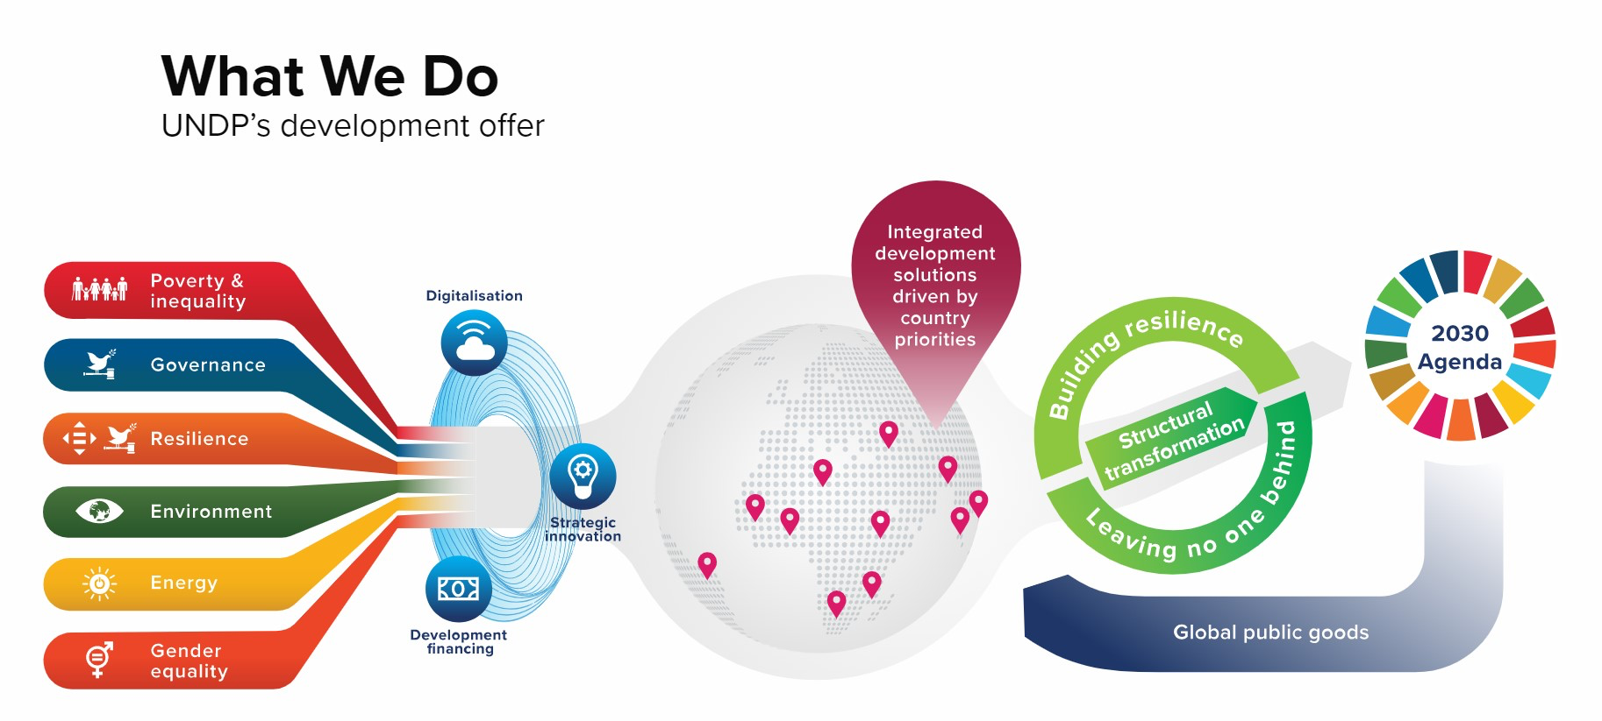
Fig 1. A flowchart of the UNDP’s Signature Solutions and how it connects to the 2030 Agenda.

The UNDP works hard to establish policies and implement projects across the globe to support these six core tenets. By advising governments, providing financial support, and coordinating with its many global partners, the UNDP drives progress towards these six signature solutions while carrying out overarching themes of sustainable development.
In addition to these signature solutions, the UNDP has a variety of programs that help aid its endeavors in development. One of these programs includes the Sustainable Development Goals (SDGs), also known as Global Goals, which serve as a call to action. These SDGs were adopted by the UN in 2015, calling for an end to poverty, the protection of the planet’s climate, peace and prosperity for all by 2030, and many others. There are a total of 17 SDGs, with topics ranging from gender equality to the implementation of affordable and clean energy.
One historical achievement of the UNDP is its establishment of the Human Development Index (HDI), which measures a variety of indicators across three dimensions: health, education, and standard of living. The health dimension is measured by life expectancy, the education dimension is measured by mean years of schooling, and the standard of living dimension is measured by the country’s gross national income per capita. This data is compiled in Human Development Reports (HDRs), analyzing the HDIs of different countries through the thematic lenses of the SDGs to determine which countries are falling behind in their commitment to development. Another historical achievement of the UNDP is its active role in conflict prevention and post-conflict recovery, including in the Syrian refugee crisis, Rwandan post-genocide recovery in 1994, and its involvement with disarmament, demobilization, and reintegration (DDR) programs for ex-combatants.

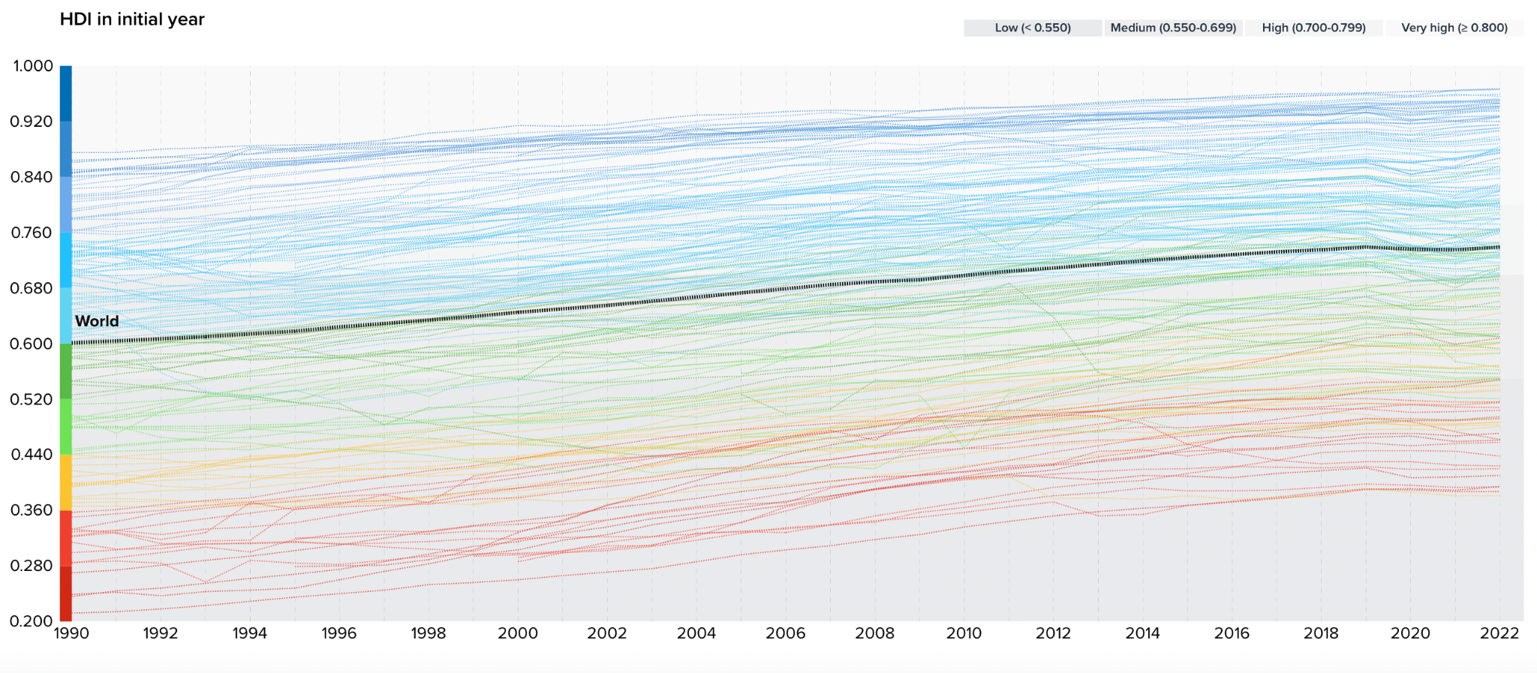
Fig 2. The latest HDI data, showing the average HDI of the world.
The UNDP has faced historical criticisms for inefficiencies and overly bureaucratic processes, as well as concerns about a lack of transparency and perceived political biases. Critics argue that its impact in key areas such as poverty reduction and inequality has been limited, with tangible, long-term progress difficult to measure. Additionally, the UNDP's heavy reliance on donor funding and voluntary contributions from member states often subjects its initiatives to the shifting priorities and agendas of those contributors. Concerns have also been raised about the sustainability of its projects, as many risk failing if funding is withdrawn, calling into question their long-term impact and viability.

Topic A. Implementation of the 2030 Agenda for Sustainable Development
Introduction
In September 2015, the United Nations adopted a global framework designed to achieve sustainable development by 2030 and advance the objectives of the Paris Agreement. This framework introduced the 17 Sustainable Development Goals (SDGs), aiming to promote sustainable development across multiple sectors—economic, social, and environmental. The 17 SDGs are listed below:
1. No poverty  2. Zero hunger  3. Good health and well-being  4. Quality education  5. Gender equality  6. Clean water and sanitation  7. Affordable and clean energy  8. Decent work and economic growth  9. Industry, Innovation, and Infrastructure | 10. Reduced inequality  11. Sustainable cities and communities  12. Responsible consumption and production  13. Climate action  14. Life below water  15. Life on land  16. Peace, justice and strong institutions  17. Partnerships for the goals

A central principle of the 2030 Agenda is the commitment to ensure that "no one is left behind." To implement this core value, the agenda follows a 3x6x3 framework—three directions of change, six signature solutions, and three enablers. Each component of this framework can be broken down as follows:

Directions of Change: These outline the key areas requiring focus to achieve sustainable development:
- Structural Transformation: Achieving the Sustainable Development Goals (SDGs) requires transforming a country’s economic and social systems. This involves fostering inclusive economies that promote innovation and support long-term growth, addressing the root causes of inequality and poverty.
- Leaving No One Behind: Inclusivity is at the heart of the 2030 Agenda, emphasizing the active inclusion of vulnerable groups, such as women, Indigenous populations, and people with disabilities, in policies and programs. By addressing systemic inequalities, sustainable development efforts can benefit all members of society.
- Building Resilience: This focuses on equipping communities to prepare for, respond to, and recover from crises such as climate change, economic hardships, or conflicts. Resilience ensures that progress toward sustainable development is not lost during challenging times.

Signature Solutions: These represent the core focus areas of development:

Poverty and inequality
- Governance
- Resilience
- Environment
- Energy
- Gender equality
Enablers: These are mechanisms that enhance the effectiveness and progress of development initiatives:
- Digitization: Digital tools and platforms expand access to education, healthcare, and other public services while enabling data-driven decision-making for governments.
- Strategic Innovation: The UNDP promotes creative solutions that drive transformative change, including new technologies and innovative financing methods to support a wide range of projects.
- Development Financing: To fund the SDGs, the UNDP mobilizes resources from international financial institutions, the private sector, and philanthropic organizations.
To achieve these ambitious goals, the UNDP and the 2030 Agenda rely on extensive global partnerships, involving institutions such as international finance organizations and academia.
The plan continues to incorporate lessons learned from global events, such as the COVID-19 pandemic. The pandemic highlighted critical challenges, including economic inequality, strain on global health systems, and disruptions in education, underscoring the need for resilience as a fundamental trait of sustainable cities. Despite these setbacks, the plan remains committed to achieving the sustainability goals outlined in the 2030 Agenda. It also seeks to address the long-lasting impacts of the pandemic by supporting affected governments and communities in their recovery efforts.
Some actions the UNDP plans to take in the next four years include helping 100 million people escape poverty, helping 500 million people gain access to clean energy, supporting 800 million people in participating in upcoming elections, and promoting expenditure and investment of over $1 trillion towards the SDGs.

History

The 2030 Agenda and its 17 Sustainable Development Goals are direct successors to the 8 Millennium Development Goals (MDGs), which were established in 2000 with a similar aim to the 2030 Agenda—to achieve certain key human development targets by 2015. Specifically, these goals were:
(1) the eradication of extreme poverty and hunger
(2) the achievement of universal primary education
(3) the promotion of gender equality
(4) the reduction of child mortality
(5) the improvement of maternal health
(6) the combat of HIV/AIDs, malaria, and other diseases
(7) the ensuring of environmental sustainability, and
(8) the development of a global partnership for human development.
While the Millennium Development Goals (MDGs) achieved some success in driving progress in certain countries, overall progress was uneven across nations. The MDGs faced criticism for the lack of analytical reasoning behind the selection of their objectives and for the insufficient use of objective indicators to measure progress, particularly in areas like gender equality (e.g., how can gender equality be measured in an unbiased and comprehensive manner?). Furthermore, critical issues such as environmental sustainability were underemphasized, and significant sectors like agriculture were notably absent from the framework.
Between the creation of the Millenium Development Goals and the writing of the current 2030 Agenda 15 years afterward, there were several intermediate steps that closely affected the way the SDGs were chosen.
The groundwork for the 2030 Agenda was laid during the UN Conference on Sustainable Development, also known as Rio+20. This conference, a 20-year follow-up to the seminal UN Conference on Environment and Development (1983), had three goals of (1) revitalizing the international effort towards sustainable development, (2) assessing obstacles and gaps in meeting previous commitments, and (3) addressing new and emerging challenges.
The idea for the Sustainable Development Goals (SDGs) was first proposed by Colombia during a preparatory event leading up to the Rio+20 conference. This proposal eventually led to the adoption of the resolution titled “The Future We Want,” which explicitly called for the establishment of the SDGs and laid the foundation for the 2030 Agenda.
Following Rio+20, the UN established an Open Working Group (OWG) composed of representatives from 30 countries. This group was tasked with drafting the Sustainable Development Goals, incorporating input from various stakeholders, including governments, civil society, and the private sector. The final version of the 2030 Agenda, along with the SDGs, was adopted by the UN General Assembly at a historic summit in New York on September 25, 2015. The Agenda emphasizes the importance of "leaving no one behind" and represents a transformative vision for global development over the next 15 years.

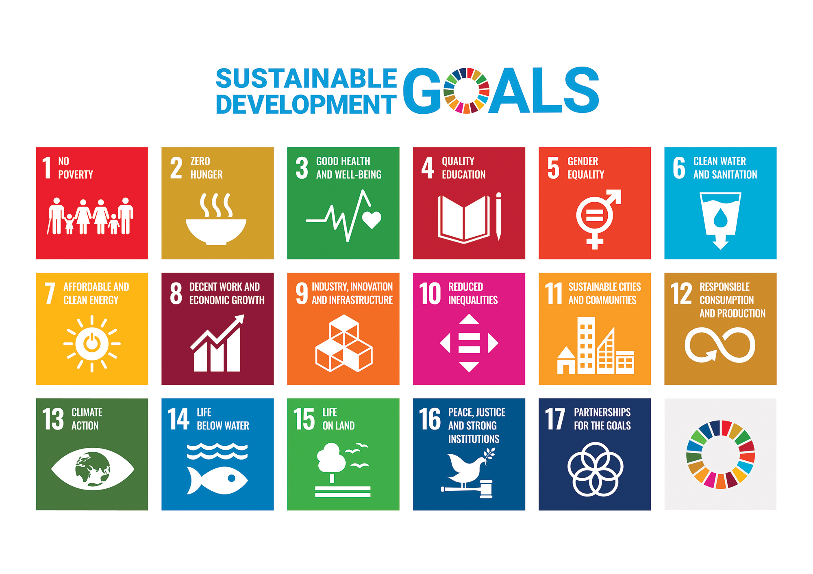
Fig 3. The 17 Sustainable Development Goals.

Current Situation
The 17 SDGs outlined in the 2030 Agenda were intended to rectify the lack of comprehensiveness in the MDGs. From the Preamble to the 2030 Agenda: “They [the 17 Sustainable Development Goals] seek to build on the Millennium Development Goals and complete what these did not achieve”. Unlike the MDGs, which were primarily focused on social issues, the SDGs recognize the interconnectedness of economic, social, and environmental factors.
This approach aims to foster balanced development that benefits both people and the planet. The SDGs apply to all countries, regardless of their level of development, emphasizing that every nation has a role in achieving sustainable development. Furthermore, the goals encompass a wide range of issues, including poverty eradication (Goal 1), quality education (Goal 4), gender equality (Goal 5), climate action (Goal 13), and partnerships for the goals (Goal 17). They aim to tackle systemic barriers to development and address both root causes and consequences of various challenges.
Yet, implementing the 2030 Agenda has presented challenges for many countries. Financial resources, data availability, policy quality, and governance structures are crucial factors that impact the progress towards achieving the SDGs. Partnerships among governments, businesses, civil society, and international organizations are seen as essential to overcome these obstacles.
For example, in an analysis of 41 high and upper-middle income countries, Glass and Newig (2019) found that of four central aspects of governance for sustainable development– participation (does the government create/execute policy?), policy coherence (are these policies mutually supportive?), reflexivity (can the government react to emergent situations quickly?), and democratic institutions (do leaders act in the public interest?)–democratic institutions are the most predictive of success to the achievement of various SDGs. On the other hand, institutional inertia and path dependency of ministerial bureaucracies pose further obstacles to strategic reorientation towards sustainable development.

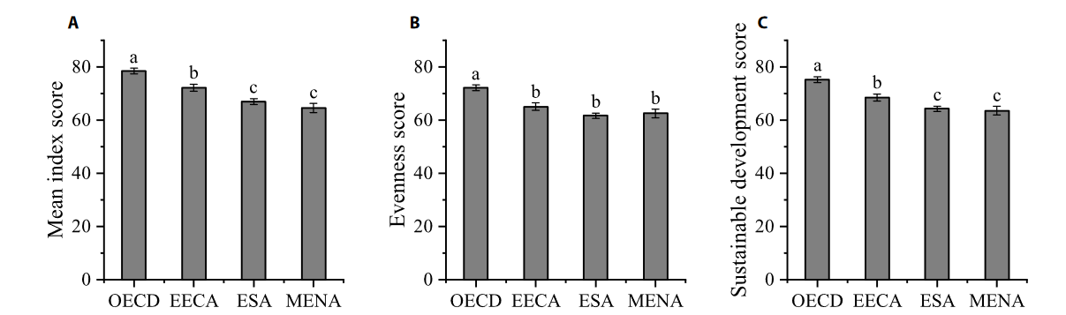
Fig 4. Mean index score (A), evenness score (B), and sustainable development score (C) of different groups in 2021. OECD, Organization for Economic Co-operation and Development; EECA, Eastern Europe and Central Asia; ESA, East and South Asia; MENA, Middle East and North Africa. Different letters represent significant differences between the 4 groups at P < 0.05. The error bars represent the standard error.
Governments worldwide have begun taking steps to align their institutions with the SDGs. Some, like the Netherlands, have established dedicated coordination bodies within central agencies, while others, such as Germany, have fostered inter-ministerial exchanges to adapt their public-administrative systems to the SDG framework. However, these efforts vary significantly across countries, leading to substantial differences in the level of institutional integration inspired by the SDGs. For instance, in some nations, responsibility for the SDGs is assigned to one or two ministries, while in others, it rests with the head of state or government. The effectiveness of these differing approaches remains uncertain and requires further evaluation.
As a result, progress on the SDGs has been uneven. Many regions lag behind due to challenges such as conflict, economic constraints, or environmental issues. It is particularly important for this committee to acknowledge that most, if not all, of these goals are highly unlikely to be achieved by 2030. The SDGs are inherently ambitious, and the outcomes reported thus far indicate a difficult road ahead. Rising inequalities, climate change, and biodiversity loss are among the critical concerns threatening progress and demanding urgent attention.
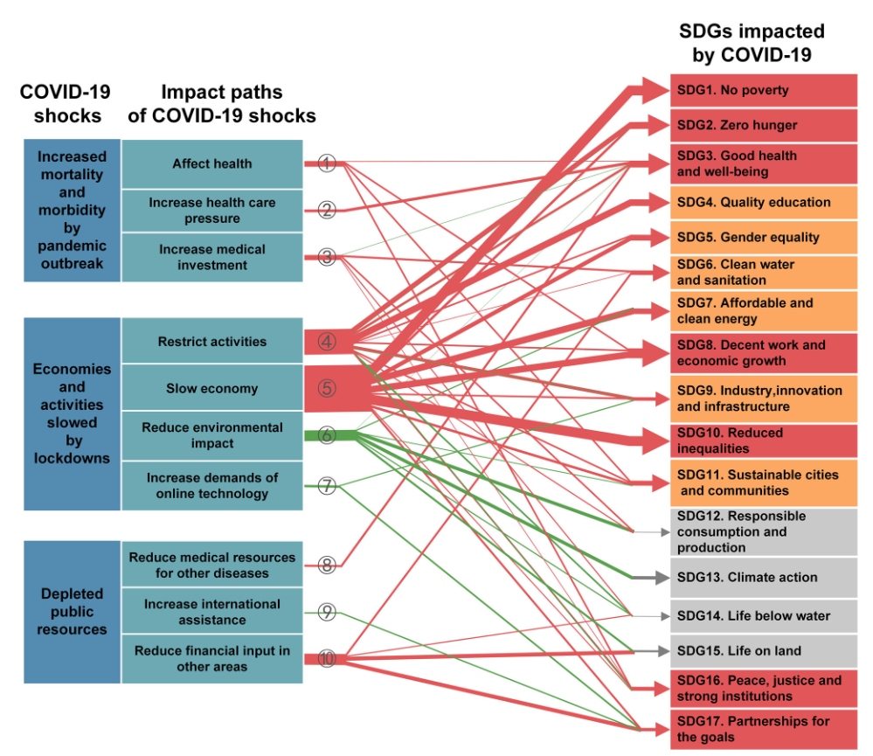
Fig 5. The nominal direct impact on each SDG of 17 in total can be caused through ten specific paths aligned with three initial COVID-19 shocks. The red color represents negative impacts, while the green indicates positive impacts and the gray means uncertain. For the SDGs, red represents the goal incurring highly negative impacts, orange represents mixed or moderate negative impacts, and gray implies uncertain overall impacts.
The COVID-19 pandemic heightened these challenges. The pandemic impacted all 17 goals and made clear the interconnectedness of global health, economic, social, and environmental challenges. Specific regions, like Asia, were more affected than others, experiencing significant setbacks during that time (specifically regarding goals 2, 8, 10, 11, and 15).
One of the most significant challenges with the SDGs, and a major obstacle to their implementation, is their lack of specificity, which makes it difficult to track meaningful progress. It remains unclear whether achieving the targets specified by the United Nations Statistics Division genuinely contributes to more ecologically, socially, or economically stable nations, or if it simply encourages temporary institutional reforms without lasting impact.
Questions a Resolution Must Answer:
- What goals for sustainable development should be the most important to focus on for countries that partake?
- How will wealthier nations help developing countries in achieving their sustainable development goals, and ensure equity in the process?
- How will countries be held or keep themselves accountable to meeting the goals and milestones that they want to achieve for SDGs?
- How can technological advancements be used, at all, for SDGs? Which goals of sustainable development will be most relevant for the technological sector?
- In what ways will sustainable development projects be financed? Will this be through private/public sector cooperation, grants, taxes?

Potential Bloc Positions
Blocs must take into account the priorities of their respective countries, as well as their infrastructure and capacity to achieve their sustainable development goals. Higher-income, developed nations may prioritize goals such as sustainable cities (SDG 11) and affordable and clean energy (SDG 7). In contrast, developing countries, particularly those with low or middle incomes, are more likely to focus on objectives such as zero hunger (SDG 2) and poverty alleviation (SDG 1).

Developed Countries (North America and Oceania)

The United States, Canada, and New Zealand focus on sustainability and climate action (SDG 13) while implementing energy-efficient solutions and transitioning to renewable energy sources (SDG 7). These nations also emphasize building smart cities and innovative urban planning to foster sustainable living (SDG 11). Their well-established infrastructure and advanced economies allow them to lead in global environmental and technological initiatives.

Developed Countries (Europe and East Asia)

European Union nations and Japan prioritize similar goals, focusing on transitioning to renewable energy (SDG 7) and addressing climate change (SDG 13). These countries also excel in creating smart cities and sustainable urban planning models (SDG 11). Their approach often integrates cutting-edge technology and policy innovation to ensure economic growth aligns with environmental goals.

Developing Countries (Sub-Saharan Africa)

Countries such as Burkina Faso, Angola, Rwanda, Somalia, and Zambia focus on eradicating hunger and poverty (SDG 1 & SDG 2). Their efforts also prioritize improving basic infrastructure, including roads, energy, and sanitation systems (SDG 9). Expanding economic opportunities and creating sustainable jobs (SDG 8) are critical goals for fostering long-term development in these regions.

Developing Countries (South Asia and Southeast Asia)

Afghanistan and Cambodia emphasize similar needs, targeting poverty alleviation (SDG 1), hunger reduction (SDG 2), and infrastructure development (SDG 9). Economic growth and job creation (SDG 8) remain central to their strategies, as they aim to stabilize and expand their economies while improving living standards for their populations.

Emerging Economies (BRICS – Urbanization Focus)

Brazil, India, and South Africa prioritize reducing urban poverty and inequality within their rapidly growing cities. Their development efforts focus on affordable housing projects and sustainable urbanization initiatives (SDG 11). These nations also invest heavily in infrastructure development to support their growing populations and economies (SDG 9).

Emerging Economies (BRICS – Economic Growth Focus)

Russia and China place significant emphasis on modernizing infrastructure and supporting large-scale development projects (SDG 9). They aim to balance urbanization demands with economic growth, addressing urban poverty and fostering innovation while aligning their strategies with sustainable development principles.

Topic B. Development of Sustainable Cities
Introduction
Urbanization stands as a defining trend of the 21st century, placing a critical emphasis on sustainable development. The United Nations Development Programme (UNDP) is dedicated to advancing sustainability within urban environments on multiple levels, as reflected in Goal 11 of the 17 Sustainable Development Goals (SDGs), which underscores the importance of cities being safe, inclusive, and resilient. As of 2018, an estimated 4.2 billion people—over half of the global population—resided in urban areas. This figure is projected to rise significantly, with experts forecasting that by 2050, 6.2 billion people will inhabit cities. Such rapid urban growth highlights the urgency of addressing urban sustainability challenges.
Although cities occupy only about 3% of the Earth’s land area, they account for over 70% of global carbon emissions and consume the majority of the planet’s natural resources. This disparity underscores the critical need to enhance sustainability within these spaces. In an urban context, sustainability involves a holistic approach that integrates economic growth, social inclusion, and environmental stewardship. The UNDP identifies several essential components of sustainable development in urban settings, including safe and affordable housing, accessible green spaces, efficient public transit, inclusive urban planning, and resilient economies.
The United Nations Environment Programme (UNEP) recognizes the importance of developing sustainable cities and assists in the commitment to SDG 11, citing areas for work such as sustainable consumption and the reduction of pollution and waste through policy, technology, and financing. For example, the UNEP and Kenyan government launched an Air Quality Monitoring Network in Nairobi to provide more accurate data on pollution levels. The UNEP also partnered with the city of Kasese (Uganda) to implement widespread solar power for homes, public buildings, and businesses, and spearheaded a project to help restore mangroves on the coast of Beira (Mozambique) to protect against flooding and rising sea levels. The UNEP works with multiple partners such as local authorities, governments, civil society, and private sector stakeholders; this topic remains an integral area for improvement among sustainability efforts.
These sustainability efforts are already evident in cities such as Amsterdam, Copenhagen, and Singapore, all of which have prioritized clean energy, pedestrian-friendly infrastructure, and the integration of green spaces. Similarly, cities in developing countries like Bogotá, Colombia, and Curitiba, Brazil, have focused on constructing and implementing affordable public transportation systems. These initiatives aim to reduce carbon emissions while enhancing accessibility for underserved communities, demonstrating how sustainable urban planning can address both environmental and social challenges.
Some challenges to these efforts include the lack of financial resources to back sustainable projects in developing countries, a lack of technological expertise to implement these systems, and government structures that prevent this sort of progress. There are also problems specific to certain types of cities. Some cities experience resource scarcity, as seen in droughts in cities like Cape Town (South Africa). Other cities are so heavily populated that air pollution due to traffic congestion in Jakarta (Indonesia) and Beijing (China) is a major roadblock in sustainability. Climate change also affects cities disproportionately, with cities like Miami (USA) and Dhaka (Bangladesh) being subjected to floods and monsoons, respectively. Sustainable development cannot tackle every single problem in the same way, which leads to roadblocks when it comes to implementing widespread policy.

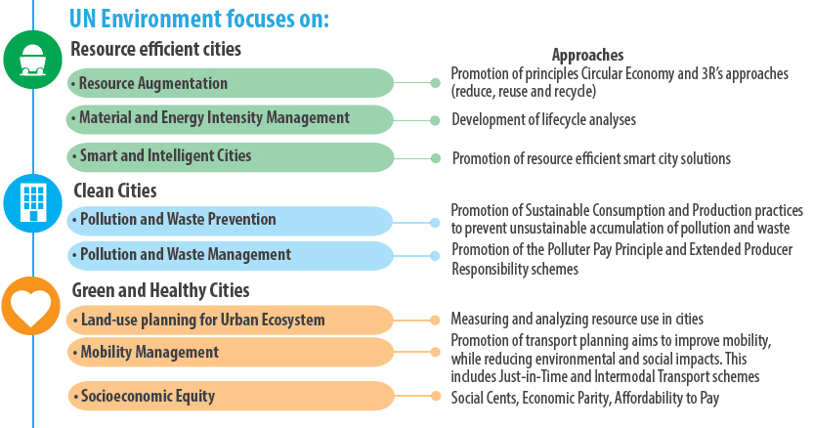
Figure 3. The UNEP’s goals and approaches for the development of sustainable cities.

History
The UN's attention to urban development is not new. Milestones in this area include the United Nations Conference on Human Settlements (Habitat I) in Vancouver in 1976, Habitat II in Istanbul in 1996, and Habitat III in Quito in 2016, which produced the New Urban Agenda. Each conference established new commitments and initiatives to address pressing urban issues. Habitat I underscored the need for adequate shelter for all, leading to stronger global commitments toward affordable housing policies. Habitat II pushed forward the concept of sustainable urbanization, fostering initiatives to improve urban governance and combat poverty in urban areas. Habitat III introduced the New Urban Agenda, focusing on integrating sustainability into all aspects of urban planning, management, and governance. This agenda has influenced national and local policies worldwide, inspiring measures such as expanded public transportation, increased green spaces, and stricter environmental regulations to reduce city pollution. These conferences have thus progressively shaped urban policies, creating ripple effects in housing quality, infrastructure, and climate resilience worldwide.
The Millennium Development Goals (MDGs) included targets on improving the lives of at least 100 million slum dwellers by 2020. However, these targets were limited primarily to basic improvements, such as access to water and sanitation, without addressing underlying issues like overcrowding, insecure land tenure, and inadequate housing. This limited scope did not provide a long-term solution to the root causes of slum proliferation, which remained largely unaddressed until the adoption of the 2030 Agenda for Sustainable Development. The growing understanding of urban areas as both a challenge and an opportunity for sustainable growth prompted the inclusion of a dedicated Sustainable Development Goal (SDG 11) when the 2030 Agenda was adopted in 2015. SDG 11, "Sustainable Cities and Communities," set ambitious targets, including access to adequate, safe, and affordable housing, accessible and sustainable transport systems, and enhanced resilience to disasters, providing a comprehensive framework for achieving more sustainable urban development. It emerged from the increasing recognition of the critical role cities play in global development and sustainability.
Urbanization trends have long driven both economic growth and social challenges. By 2050, it is estimated that around 68% of the world’s population will live in urban areas. The dramatic urban expansion highlighted the urgent need for sustainable urban development to address issues like overcrowding, pollution, inadequate infrastructure, and inequality.
The inclusion of SDG 11 recognizes that sustainable urbanization is crucial to addressing many global challenges, from poverty and inequality to climate change and resource efficiency. The goal aims to improve housing, access to safe and affordable transport, urban planning, cultural heritage preservation, disaster risk reduction, air quality, and waste management. The interconnectedness of cities with other goals—such as clean water (SDG 6), affordable energy (SDG 7), economic growth (SDG 8), and climate action (SDG 13)—underscored the importance of cities as hubs of both risks and solutions.
Current Situation
SDG 11 can be thought of as the current UN standing on how best to encourage better urban living conditions via international consensus. Within the context of SDG 11 are 10 specific targets being tracked by 15 indicators of progress. The targets are:
1. Safe and affordable housing
2. Affordable and sustainable transport systems
3. Inclusive and sustainable urbanization
4. Protect the world’s cultural and national heritage
5. Reduce the adverse effects of natural disasters
6. Reduce the environmental impacts of cities
7. Provide access to safe and inclusive green and public spaces
8. Strong national and regional development planning
9. Implement policies for inclusion, resource efficiency, and disaster risk reduction
10. Support least developed countries in sustainable and resilient building
Progress towards SDG 11 has primarily been hindered by financing issues, but other challenges include governance challenges, and the impacts of climate change, and international conflict. The COVID-19 pandemic further exacerbated urban inequalities, making the need for resilient infrastructure and inclusive urban planning more apparent. In support of SDG 11, the UN has established many new supporting programmes and resolutions:
- UN-Habitat: The United Nations Human Settlements Programme (UN-Habitat) is the main body responsible for promoting sustainable urban development. It seeks to advance SDG 11 through policy guidance, technical expertise, and aid programs. For example, UN-Habitat’s “Cities Investment Facility” promotes investment in sustainable urban projects, focusing on reducing barriers for financing.
- The New Urban Agenda: Adopted in 2016 at Habitat III, this agenda complements SDG 11 by providing a comprehensive vision for sustainable urban development. It emphasizes a move to the “smart city” model, utilizing urban planning as a means for social change, and considering the consequences
- High-Level Political Forum (HLPF): The HLPF, the UN's central platform for reviewing SDG implementation, has repeatedly focused on urban development, assessing the progress of SDG 11 in its annual meetings. It has encouraged member states to incorporate urban sustainability into national plans and align local initiatives with the 2030 Agenda.
- Global Platform for Sustainable Cities (GPSC): Launched by the World Bank in partnership with the UN, this platform supports cities in implementing sustainable urban development practices.
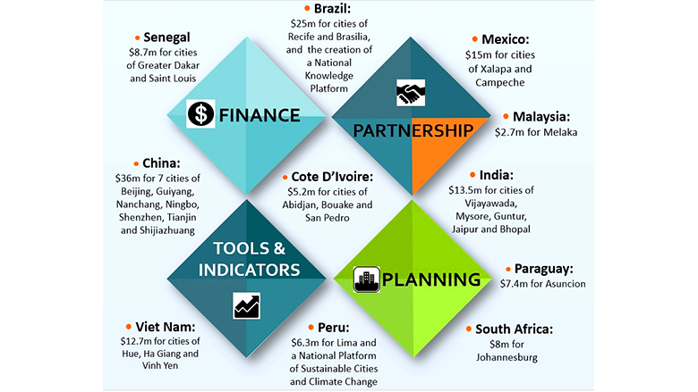
Figure 3. The GPSC covers 30 cities in 11 different countries.
Challenges In Implementation
In the past few years, progress towards SDG 11 has had significant regional differences. While the percentage of people living in slums has decreased globally since 2000, the rate of urbanization has outpaced the ability to provide adequate services, and slum populations have been rising in absolute terms in many countries, particularly in sub-Saharan Africa. There have been advances in improving access to public transport in many cities, but the COVID-19 pandemic disrupted public transit usage and funding, impacting progress.
Although methods of monitoring air quality have advanced steadily, pollution levels remain high in many developing cities remain high and are exacerbated by climate change effects as well. The adoption of sustainable urban planning practices has improved, with an increase in integrated plans that consider environmental and social dimensions. The Voluntary Local Reviews (VLRs) have become a tool for cities to report on their SDG progress, inspired by the Voluntary National Reviews (VNRs) done at the country level.
Questions a Resolution Must Answer:
- How will sustainable cities be financed, and how can this funding be sustainable long-term (ex: revenue through taxation, international donors or banks, financial institutions)
- How will the benefits of building and expanding sustainable cities be provided for all individuals, especially lower-income and marginalized groups? How will countries plan to distribute these benefits equitably?
- Will the development of sustainable cities lead to significant changes in how the economy is structured and the types of jobs that people will hold? How will individuals be trained in these career paths?
- How will sustainable cities adapt to environmental challenges, and what projects and/or technologies can be put into place to reduce and mitigate risks from climate change?
- How will the progress and success of sustainable cities be measured? What kinds of criteria and indicators will allow us to understand the impact of these cities?
Potential bloc positions
- Developed countries such as the US, members of the European Union, New Zealand, Canada, Japan, and other developed countries with advanced economies - focused on using new and advanced technologies for smart cities, as well as renewable energy and green infrastructure for sustainable practices. They also emphasize the reduction of emissions, and making cities climate resilient.
- Developing countries such as Burkina Faso, Angola, Rwanda, Afghanistan, Cambodia, Somalia, Yemen, Zambia, and many other countries that have low urban infrastructure - focused on urban population growth, as well as sustaining transportation, and improving access to affordable housing, electricity, sanitation. The major problem for many developing countries is finding funding.
- Countries: Brazil, Russia, India, China, South Africa (BRICS) - focused on encouraging renewable energy use, promoting public transportation for densely populated areas in urban cities, and usage of technology to manage public services.
Conclusion
The United Nations Development Programme plays an integral role in addressing the global challenges seen across both developed and developing nations. As the entity that established the 17 Sustainable Development Goals, the UNDP works to implement SDGs and foster inclusive growth, protect the environment, and ensure that no country is left behind. With the UNDP’s commitment to the 2030 Agenda for Sustainable Development and the development of sustainable cities, there is plenty of work to be done and challenges to overcome in the implementation of these strategies. Only through collaboration between governments and international organizations will the UNDP be able to achieve long-term sustainability across the globe.

https://www.undp.org/sustainable-development-goals
https://strategicplan.undp.org/?_gl=1*1wh5h0d*_gcl_au*MTczNDYzNjk4OC4xNzI3NzU2OTM0*_ga*MzAyNTgzNjE2LjE3Mjc3NTY5MzU.*_ga_3W7LPK0WP1*MTcyNzc1NjkzNC4xLjEuMTcyNzc2MDE0OC41OC4wLjA.
https://www.unep.org/regions/asia-and-pacific/regional-initiatives/supporting-resource-efficiency/sustainable-cities
https://sdgs.un.org/2030agenda
Vaidya, Hitesh, and Tathagata Chatterji. 2020. “SDG 11 Sustainable Cities and Communities.” In Actioning the Global Goals for Local Impact: Towards Sustainability Science, Policy, Education and Practice, eds. Isabel B. Franco, Tathagata Chatterji, Ellen Derbyshire, and James Tracey. Singapore: Springer, 173–85. doi:10.1007/978-981-32-9927-6_12.
Küfeoğlu, Sinan. 2022. “SDG-11: Sustainable Cities and Communities.” In Emerging Technologies : Value Creation for Sustainable Development, ed. Sinan Küfeoğlu. Cham: Springer International Publishing, 385–408. doi:10.1007/978-3-031-07127-0_13.
https://www.undp.org/sites/g/files/zskgke326/files/publications/Bangladesh_D10_web.pdf
https://www.undp.org/india/publications/joint-evaluation-international-response-indian-ocean-tsunami
https://www.undp.org/gender-crisis/publications/10-point-action-agenda-advancing-gender-equality-crisis-settings-10paa
Biermann, Frank, Thomas Hickmann, Carole-Anne Sénit, and Leonie Grob. 2022. “The Sustainable Development Goals as a Transformative Force?: Key Insights.” In The Political Impact of the Sustainable Development Goals: Transforming Governance Through Global Goals?, eds. Carole-Anne Sénit, Frank Biermann, and Thomas Hickmann. Cambridge: Cambridge University Press, 204–26. doi:10.1017/9781009082945.009.
https://www.iqair.com/us/kenya/nairobi
https://www.undp.org/sites/g/files/zskgke326/files/2023-01/Solar%20PV%20Installation%20in%20Uganda.pdf
https://www.undp.org/asia-pacific/publications/mangroves-future
“Let’s Get the SDGs Back on Track | SEI,” accessed October 2, 2024, https://www.sei.org/perspectives/lets-get-the-sdgs-back-on-track/.
In the Sustainable Development Goals (SDGs), targets numbered with letters, like "11.a" or "11.b," are considered "means of implementation" targets, meaning they focus on the processes and policies needed to achieve the main outcome targets which are numbered with just numbers (like "11.1" or "11.2") within each SDG; essentially, the letter-based targets outline how to put the numbered goals into action.
https://hdr.undp.org/data-center/human-development-index#/indicies/HDI

